|  |  |
| --- | --- |
| **Name:** | **Form: 4 -** |

**Діагностична робота з англійської мови**

**для учнів 4 класу**

**за курс І семестру 2021-2022 н.р.**

**1. Послухай тексти за посиланням і правильно пронумеруй малюнки. *Listening.***

<https://drive.google.com/file/d/1hDYVjVdNcKS6PCECL58RRpIDVjkDXsv-/view?usp=sharing>

****************

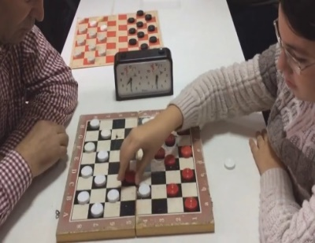********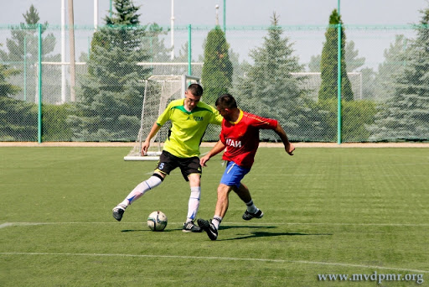****



**2.** **Прочитай. Встав потрібні слова замість малюнків. *Reading.***

**In my Town**



There are a lot of _____________________ in my town.



There is a ______________________________ with vegetables.



There is a ______________________________ with fresh bread.

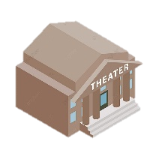

There is a ______________________. We watch performances there.

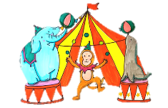

There is a ___________________________ next to the theatre. It’s great!

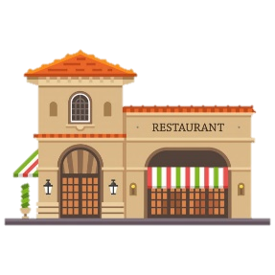

There is a _________________________opposite the circus in my town.

**3. Обери правильний початок питального речення. Запиши. *Writing.***

***How much / How many***

**1. __________________________________** bananas will you need?

**2. __________________________________** sugar will you need?

**3. __________________________________** tomatoes will you need?

**4. __________________________________** mushrooms will you need?

**5. __________________________________** butter will you need?

**6. __________________________________** cherries will you need?

**4. Розглянь малюнки і склади діалоги. *Speaking.***

**Запиши свої діалоги та надішли мені їх на електрону пошту.**

***Починай з How many / How much***

